Code 1:



Output:

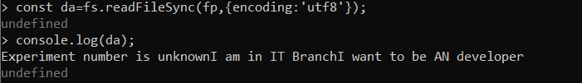

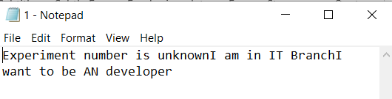

Code 2: